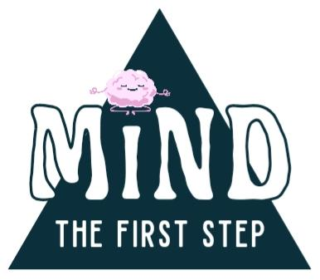

MENTAL HEALTH SCREENER, SELF-REPORT (MHS-SR)
Developed by MIND the First Step, 2024
MINDtheFirstStep.com

Module 1 | Basic Information
Name
Date

INFORMED CONSENT
If mental health symptoms are having a significant negative impact on your life, please contact a licensed professional mental health provider. If having thoughts of suicide, please contact the Suicide & Crisis Lifeline (dial or text 988), seek emergency medical care, or request crisis intervention from a local counselor.
This screener cannot be used to diagnose a mental health disorder or provide a quantitative assessment of your mental health. A “screener” helps identify possible signs of mental health concerns, therefore allowing an individual to decide if they need further support and at what level. “Self-report” simply means that you are filling out this document for yourself, without the aid of a counselor or psychiatrist.
This screener, in particular, is a helpful tool for (a) identifying current “problem areas"—AKA your opportunities for growth, (b) developing a plan for achieving your mental health goals, (c) understanding your position on the Spectrum of Mental Wellness, and (d) addressing your overall mental health needs more effectively.

INSTRUCTIONS
Part A | Completing the Questionnaire
Fill out Modules 2 - 13 to the best of your ability.
Answer honestly and do not overthink the questions.
Consider your answers in context to the last 30 days.

Part B | Reflecting on Your Answers
At the end of this questionnaire, see Part B for further instructions.
Module 2 | Self-Perception
Assessing | Statement | strongly disagree | disagree | neutral | agree | strongly agree
Self-identity | I rarely question, “Who am I?” | ☐ | ☐ | ☐ | ☐ | ☐
Self-concept | I am a good person. | ☐ | ☐ | ☐ | ☐ | ☐
Self-compassion | I forgive myself when I make a mistake. | ☐ | ☐ | ☐ | ☐ | ☐
Self-esteem | I am worthy of love and happiness. | ☐ | ☐ | ☐ | ☐ | ☐
Self-efficacy | I can do anything I set my mind to. | ☐ | ☐ | ☐ | ☐ | ☐
Self-image | I am satisfied with the way I look. | ☐ | ☐ | ☐ | ☐ | ☐

Module 3 | Life Balance
Assessing | Statement | strongly disagree | disagree | neutral | agree | strongly agree
Interpersonal | The people in my life motivate me to do my best. | ☐ | ☐ | ☐ | ☐ | ☐
Professional | I value my commitment to work/school. | ☐ | ☐ | ☐ | ☐ | ☐
Physical | My physical health does not hold me back from doing what I want to do. | ☐ | ☐ | ☐ | ☐ | ☐
Security | I feel safe at home. | ☐ | ☐ | ☐ | ☐ | ☐
Financial | I do not struggle to pay my bills on time. | ☐ | ☐ | ☐ | ☐ | ☐
Leisure | I enjoy my hobbies and interests. | ☐ | ☐ | ☐ | ☐ | ☐
Spiritual | I have a connection to something greater than myself. | ☐ | ☐ | ☐ | ☐ | ☐

Module 4 | Emotional Wellbeing
Assessing | Statement | strongly disagree | disagree | neutral | agree | strongly agree
Adaptability | I am able to “go with the flow” when unexpected things happen. | ☐ | ☐ | ☐ | ☐ | ☐
Motivation | I complete most tasks that I start. | ☐ | ☐ | ☐ | ☐ | ☐
Conflict Resolution | I don’t have to yell to make my point heard. | ☐ | ☐ | ☐ | ☐ | ☐
Self-regulation | My behavior never feels “out of my control.” | ☐ | ☐ | ☐ | ☐ | ☐
Self-regulation | It's easy to stop thinking negative thoughts and focus on something else. | ☐ | ☐ | ☐ | ☐ | ☐
Self-regulation | I can usually calm myself down after feeling overwhelmed. | ☐ | ☐ | ☐ | ☐ | ☐
Adaptability | I don’t worry about small things that are out of my control (traffic, weather). | ☐ | ☐ | ☐ | ☐ | ☐
Resilience | My past does not define me. | ☐ | ☐ | ☐ | ☐ | ☐
Resilience | I see my failures as a learning experience. | ☐ | ☐ | ☐ | ☐ | ☐
Empathy | I can easily take the perspective of people who are different from me. | ☐ | ☐ | ☐ | ☐ | ☐
Outlook | I am hopeful for the future. | ☐ | ☐ | ☐ | ☐ | ☐
Self-awareness | I can easily identify what emotions I'm feeling. | ☐ | ☐ | ☐ | ☐ | ☐
Self-awareness | I am aware of my strengths and weaknesses. | ☐ | ☐ | ☐ | ☐ | ☐

Module 5 | Social-Emotional Skill Set
Assessing | Statement | strongly disagree | disagree | neutral | agree | strongly agree
Mindfulness | I rarely dwell on the past/future. | ☐ | ☐ | ☐ | ☐ | ☐
Mindfulness | I often notice things like the breeze or the way my food smells. | ☐ | ☐ | ☐ | ☐ | ☐
Acceptance | I accept things for the way they are, not how I wish they would be. | ☐ | ☐ | ☐ | ☐ | ☐
Acceptance | I allow myself to feel all of my feelings, good and bad. | ☐ | ☐ | ☐ | ☐ | ☐
Boundaries | I am not scared to tell people where my personal boundaries are. | ☐ | ☐ | ☐ | ☐ | ☐
Boundaries | No one can push me into doing something I am uncomfortable with. | ☐ | ☐ | ☐ | ☐ | ☐
Communication | I am rarely misunderstood when I talk to people. | ☐ | ☐ | ☐ | ☐ | ☐
Communication | When other people are talking, I make sure to listen closely. | ☐ | ☐ | ☐ | ☐ | ☐
Communication | I can calmly talk to most people, even if their beliefs are different to mine. | ☐ | ☐ | ☐ | ☐ | ☐
Gratitude | When I’m having a bad day, I can still see the good things that happen. | ☐ | ☐ | ☐ | ☐ | ☐

Module 6 | Physical Wellbeing
Assessing | Statement | strongly disagree | disagree | neutral | agree | strongly agree
Sleep | When I wake up from sleeping, I feel well-rested. | ☐ | ☐ | ☐ | ☐ | ☐
Coordination | I rarely loose my balance or accidentally knock things over. | ☐ | ☐ | ☐ | ☐ | ☐
Intimacy | I am satisfied with the level of physical and emotional intimacy in my life. | ☐ | ☐ | ☐ | ☐ | ☐
Energy | I rarely feel exhausted at the end of the day or unable to get up in the mornings. | ☐ | ☐ | ☐ | ☐ | ☐
Diet | My meals usually contain a balance of vegetables, protein, and carbs. | ☐ | ☐ | ☐ | ☐ | ☐
Exercise | I have a consistent routine of physical movement/exercise. | ☐ | ☐ | ☐ | ☐ | ☐
Discomfort | I do not experience chronic pain or physical discomfort. | ☐ | ☐ | ☐ | ☐ | ☐

Module 7 | Cognitive Wellbeing
Assessing | Statement | strongly disagree | disagree | neutral | agree | strongly agree
Learning | I'm capable of learning new concepts at work/school. | ☐ | ☐ | ☐ | ☐ | ☐
Memory | I can easily recall names or remember meaningful past events. | ☐ | ☐ | ☐ | ☐ | ☐
Sensory | My senses (sight, sound, taste, touch, and smell) function normally for me. | ☐ | ☐ | ☐ | ☐ | ☐
Attention | I can tune out background noises to focus on what's important. | ☐ | ☐ | ☐ | ☐ | ☐
Processing | I feel clear-headed and able to process information quickly. | ☐ | ☐ | ☐ | ☐ | ☐

Module 8 | Social Wellbeing
Assessing | Statement | strongly disagree | disagree | neutral | agree | strongly agree
Independence | I am comfortable being alone. | ☐ | ☐ | ☐ | ☐ | ☐
Family | I feel supported by my family. | ☐ | ☐ | ☐ | ☐ | ☐
Community | Outside of family, I have a support system to lean on (friends, church, social group). | ☐ | ☐ | ☐ | ☐ | ☐

Module 9 | Self-Reported Position on the Spectrum of Mental Wellness

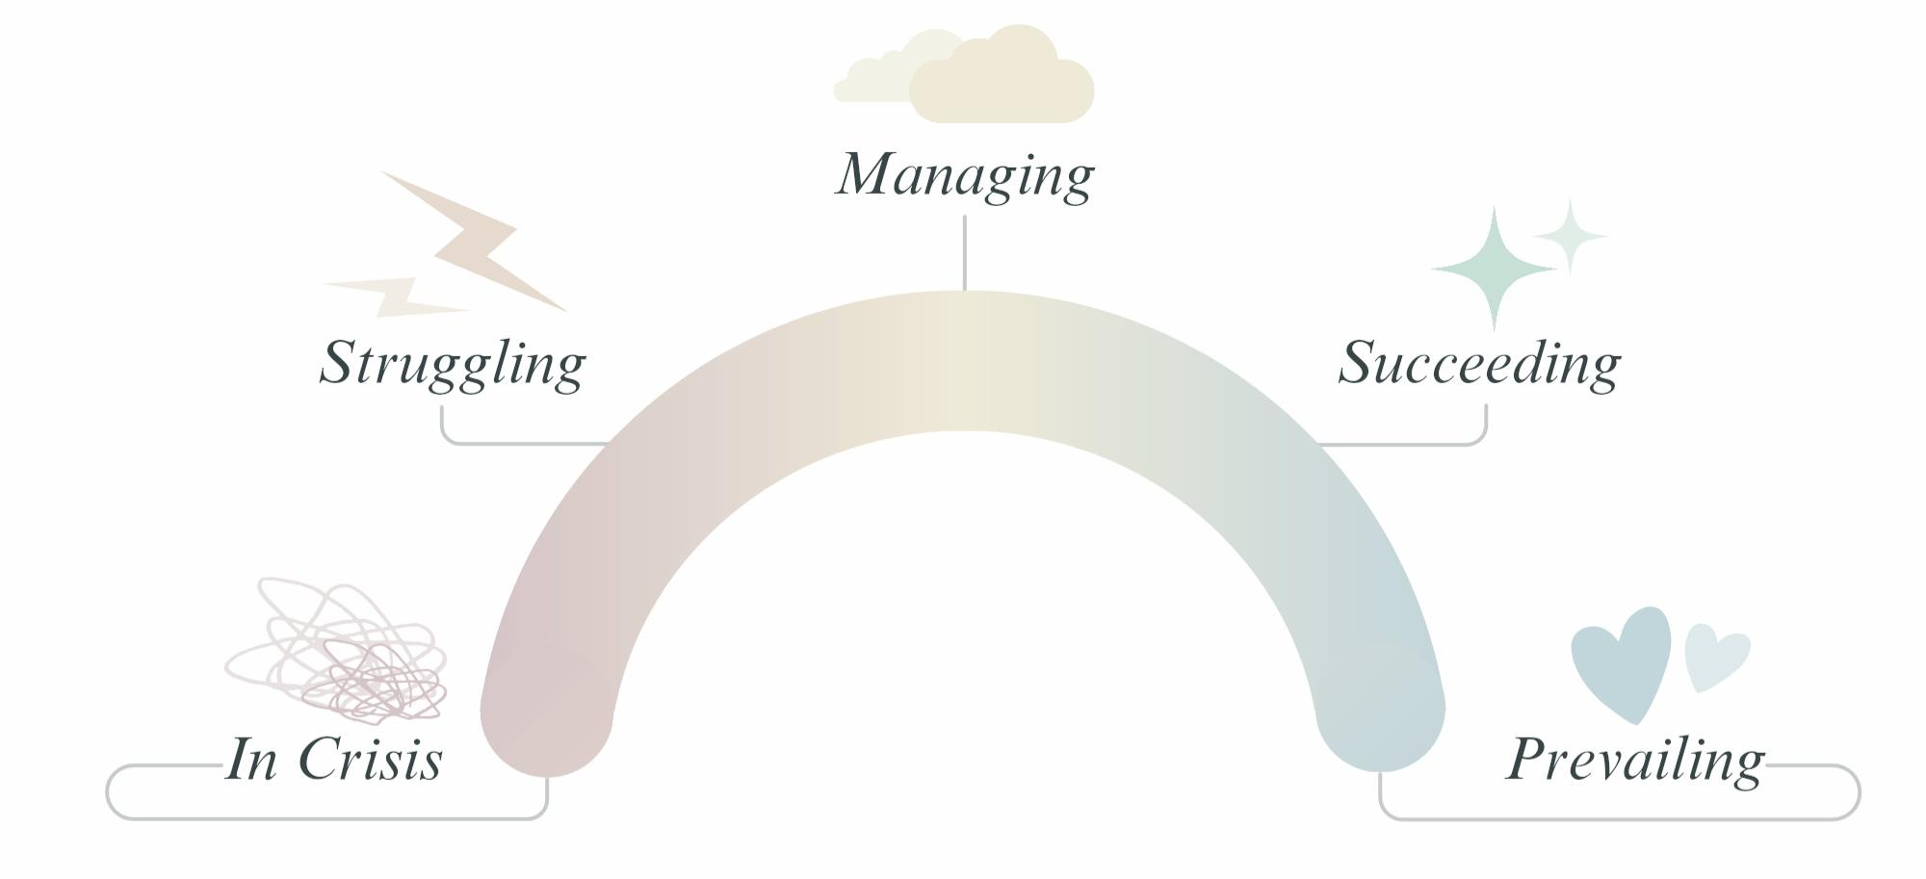
Mental health is a dynamic trait, so your position will move up and down the spectrum at different points in your life. Considering the last 30 days, which position describes you the best?
☐ Prevailing | Exhibits high social-emotional intelligence and a positive mood. Utilizes positive coping skills to manage any negative mental health symptoms. Holds authority over their thoughts, feelings, and behaviors. Achieves success at work and pursues social/personal interests. Life is fulfilling and has purpose.

☐ Succeeding | Exhibits predictable mood and contentment. Manages negative mental health symptoms, but not as effectively. Feels like their mental health is “good enough," so doesn't spend as much time practicing wellness strategies. Finds success in work and hobbies, but feels underlying stress or insecurity.

☐ Managing | Exhibits fluctuating mood with regular highs and lows; often feels like “life is harder than it should be.” Unable to manage negative mental health symptoms or practice positive coping. Often content, but easily distracted by negativity and worry. Seeks a better path forward, not sure where to start.

☐ Struggling | Exhibits unpredictable mood and negative coping habits. Focus is on “getting through the day,” so emotional needs are rarely met. Negative mental health symptoms are unmanaged, creating greater emotional turbulence and unhealthy relationship dynamics. Overwhelmed, seeks a quick solution.

☐ In Crisis | Routine suffering from negative mental health symptoms; unable to function in daily life or maintain healthy relationships. May be at risk of harming themselves or others. Requires crisis intervention to get back on track--please seek professional mental health support if in this category.

Module 10 | Symptoms of Mental Distress

Have you experienced any of these symptoms within the last 30 days? Select the degree of impact (none, mild, moderate, significant, severe) each symptom has had on your ability to function.

 |  | none | mild | moderate | significant | severe
1 | Feeling sad or down | ☐ | ☐ | ☐ | ☐ | ☐
2 | Reduced ability to concentrate, confused  thinking, or feeling “foggy-headed" | ☐ | ☐ | ☐ | ☐ | ☐
3 | Excessive fears or worries | ☐ | ☐ | ☐ | ☐ | ☐
4 | Extreme mood changes | ☐ | ☐ | ☐ | ☐ | ☐
5 | Withdrawal from friends and activities | ☐ | ☐ | ☐ | ☐ | ☐
6 | Significant tiredness, low energy, or  issues with sleep | ☐ | ☐ | ☐ | ☐ | ☐
7 | Detachment from reality, paranoia, or hallucinations | ☐ | ☐ | ☐ | ☐ | ☐
8 | Inability to cope with daily problems or stress | ☐ | ☐ | ☐ | ☐ | ☐
9 | Trouble understanding and relating to  situations and people | ☐ | ☐ | ☐ | ☐ | ☐
10 | Alcohol or substance misuse | ☐ | ☐ | ☐ | ☐ | ☐
11 | Major changes in eating habits | ☐ | ☐ | ☐ | ☐ | ☐
12 | Major changes in sex drive | ☐ | ☐ | ☐ | ☐ | ☐
13 | Excessive anger, hostility, or violence | ☐ | ☐ | ☐ | ☐ | ☐
14 | Chronic or unbearable stress | ☐ | ☐ | ☐ | ☐ | ☐
15 | History of stress or trauma within your lifetime | ☐ | ☐ | ☐ | ☐ | ☐

Module 11 | Degree of Stress
 |  | What has your level of stress been across the last 30 days? | ☐low | ☐med | ☐high
 |  | Is your level of stress having a significant or prolonged impact on your wellbeing? | ☐yes | ☐no
List stressors from within the last 30 days: | 1.
 | 2.
 | 3.
 | 4.

Module 12 | History of Stress or Trauma
 |  | What has your level of stress been across your lifetime? | ☐low | ☐med | ☐high
 |  | Is your history of stress having a significant or prolonged impact on your wellbeing? | ☐yes | ☐no
List stressors from within your lifetime: | 1.
 | 2.
 | 3.
 | 4.

Module 13 | Protective Factors
List the positive things in your life right now: | 1.
 | 2.
 | 3.
 | 4.
INSTRUCTIONS CONTINUED
Part B | Reflecting on Your Answers
Modules 2 - 8: A response of strongly disagree or disagree indicates “problem areas”—these are your opportunities for growth. A response of agree or strongly agree signs of wellness and positive coping—these are your strengths. A response of neutral is somewhere in the middle.
Module 9: Your position on the Spectrum of Mental Wellness provides a benchmark for determining progress. Think about where you are now and where you want to be. How do you get there?
Module 10: This section identifies symptoms of an underlying mental health concern. Please consider speaking with a professional if these issues are significantly and negatively impacting your life.
Modules 11 - 12: These sections identify the origins of harmful stress, past and present. If stress/trauma hinders your ability to carry out everyday tasks, please seek professional guidance.
Module 13: This section highlights the positive aspects of your life--the protective factors which help to alleviate/manage mental distress. Both positive and negative factors contribute to your total wellbeing.

Action Plan for Wellness | Reflect on Your “Problem Areas"
Use the chart below to list your most pressing mental health concerns and methods for improvement.
 | “Problem Area" | Action to Take  (short-term goals) | Ideal Outcome  (long-term goals)
Example | I often feel lonely. | Seek one-on-one counseling, read a book on self-esteem, schedule self-care dates… | I am comfortable being alone. I feel self-confident, even when alone…

Ideal Outcomes can be used as positive affirmations. Repeat these phrases to yourself each day to rewire your thinking patterns.

